Options Available for Tribes to Meet Independent Performance Evaluation Requirements for the Ambient Air Monitoring Programs Collecting Data for Comparison to the NAAQS

Introduction

One monitoring goal, as described in the 1990 Amendments to the Clean Air Act, is to:

“(2) Establishment of a national network to monitor, collect, and compile data with quantification of uncertainty in the status and trends of air emissions, deposition, air quality, surface water quality, forest condition, and visibility impairment and to ensure the comparability of air quality data collected in different states and obtained from different nations.” (excerpt from Section 103)

The Ambient Air Quality Monitoring Network, as well as other ambient air related networks (i.e., IMPROVE, Castnet, NADP) have been developed to collect this vital air data. It is very important to people and organizations concerned with human health and the welfare of our communities and ecosystems that the ambient air data collected from monitoring organizations are of acceptable and comparable quality. It can be very frustrating to review data and see pollutant concentrations change by 10 or 15% at the border, or from one monitoring organization to another. It can also be very frustrating to data users when the precision or bias of the data is not known. Many scientists feel that data are unusable if it is of unknown quality. The QA regulations, set forth in 40 CFR Part 58 Appendix A (hereafter referred to as Appendix A) has been developed to ensure that monitoring programs are well planned so that it is known what data quality is needed, that checks are included to assess data quality, and corrective actions are in place to improve quality systems when needed.

Most of the QA requirements in Appendix A are performed by the monitoring organization. These checks are very important and should be submitted to AQS along with routine data since it allows people using the information to assess the quality of the monitoring data. Attachment 1 provides a review of these checks in more detail. Other requirements, like the National Performance Audit Program (NPAP) and the PM_{2.5} Performance Evaluation Program (PEP), are the responsibility of the monitoring organizations, but in most cases, are being performed through federally implemented programs using State and Tribal Assistance Grant (STAG) funds.

The Appendix A QA requirements are specific to data that are collected for comparison to the National Ambient Air Quality Standards (NAAQS). Tribes monitoring for NAAQS comparison purposes must follow these requirements, including participation in the NPAP and PEP programs. Tribes monitoring for other purpose are strongly encouraged to participate in these two programs, but it is not a requirement. Some of the options discussed in the following sections may make the implementation of these audits attractive to the tribes, even if the intent of data collection is other than NAAQS comparison.

Many tribal monitoring organizations are interested in participating in these independent performance evaluations. However, due to the manner in which the requirements have been promulgated, the STAG funding necessary for implementation, and some of the logistical constraints associated with implementation, many tribes have not participated in these programs. The intent of this document is to provide some background on the EPA’s various independent QA programs and provide some options to increase tribal monitoring organization participation in these important programs.

Performance Evaluations- What are they?

Performance evaluations (PEs) are a type of audit in which the quantitative data generated in a measurement system are obtained independently and compared with routinely obtained data to evaluate the proficiency of an analyst, or a laboratory. The National Performance Evaluation Programs:

- Allow one to determine data comparability and usability across sites, monitoring networks (tribes, states, and geographic regions), instruments and laboratories.
- Provide a level of confidence that monitoring systems are operating within an acceptable level of data quality so data users can make decisions with acceptable levels of certainty.
- Help verify the precision and bias estimates performed by monitoring organizations.
- Identify where improvements (technology/training) are needed.
- Assure the public of non-biased assessments of data quality.
- Provide a quantitative mechanism to defend the quality of data.
- Provide information to monitoring organizations on how they compare with the rest of the nation, in relation to the acceptance limits and to assist in corrective actions and/or data improvements.

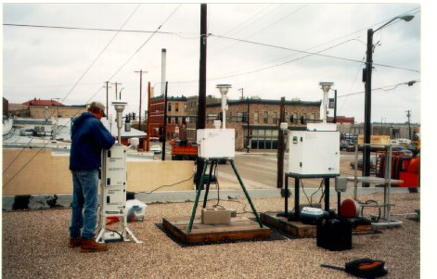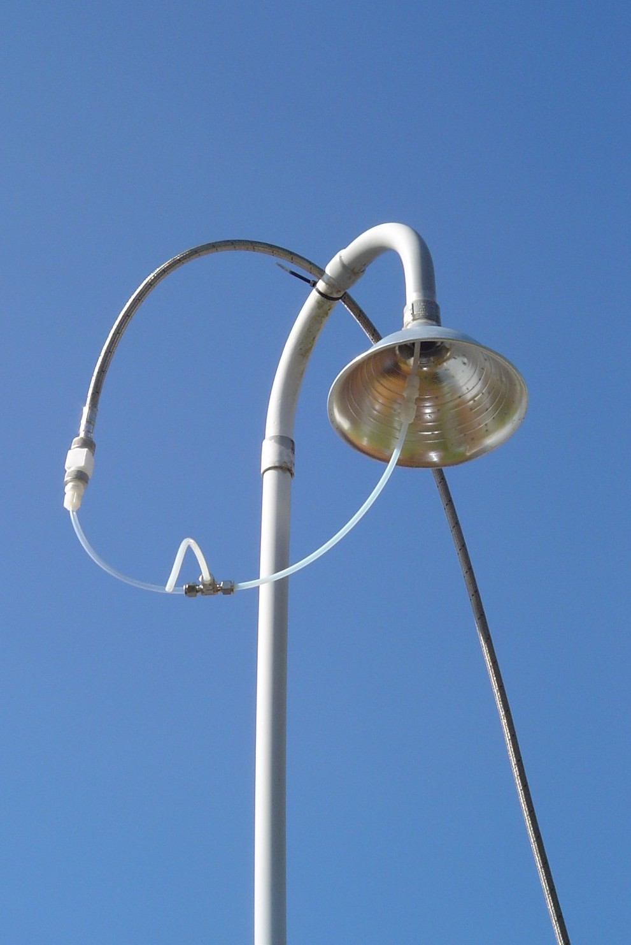Some type of national PE program is implemented for all of the ambient air monitoring activities. Table 1 provides more information on these activities. These nationally implemented performance evaluations provide for assessments of comparability that are typically not being performed by any other entity within the ambient air monitoring community. In addition, it’s important that these performance evaluations be independent in order to ensure they are non-biased and objective. With the passage of the Data Quality Act, there is potential for EPA to receive challenges to the quality of the ambient air data. Independent audits help provide another piece of objective evidence on the quality of a monitoring agencies data and can help EPA defend the quality of the data.
PEP Audit
NPAP through the probe audit

Although Table 1 lists seven performance evaluation programs operating at the federal level, the two of prime importance for this document are the NPAP and PEP Programs. Additional information on both programs can be found on the AMTIC Website. The October 17, 2006 monitoring rule identifies the monitoring organizations as responsible for ensuring the implementation of these audits. Monitoring organizations can either implement the program itself or continue to participate in the federally implemented program. Over the years, a number of tribes have participated in both the NPAP and PEP Programs. The tribes have found the data useful since it provides an independent check on the quality of their programs and also allows for trouble shooting and program improvement when an audit is found to be outside acceptance ranges.

Table 1 National Performance Evaluation Activities Performed by EPA
Program/  Lead Agency | Explanation
NPAP  OAQPS | National Performance Audit Program provides audit standards for the gaseous pollutants either as devices that the site operator connects to the back of the instrument or through the probe in which case the audits are conducted by presenting audit gases through the probe inlet of ambient air monitoring stations. Flow audit devices and lead strips are also provided through NPAP. NPAP audits are required at 20% of a primary quality assurance organizations sites each year with a goal of auditing all sites in 5-7 years.
PM_{2.5} PEP  OAQPS | PM_{2.5} Performance Evaluation Program. The strategy is to collocate a portable FRM PM_{2.5} air sampling audit instrument with an established primary sampler at a routine air monitoring site, operate both samplers in the same manner, and then compare the results. Each year five PEP audits are required for primary quality assurance organizations (PQAOs) with less than or equal to 5 monitoring sites or eight audits are required for PQAOs with greater than five sites. These audits are not required for PM₁₀
NATTS PT  OAQPS | A National Air Toxics Trend Sites (NATTS) proficiency test (PT) is a type of assessment in which a sample, the composition of which is unknown to the analyst, is provided to test whether the analyst/laboratory can produce analytical results within the specified acceptance criteria. PTs for volatile organic carbons (VOCs), carbonyls and metals are performed quarterly for the ~22 NATTS laboratories
SRP  ORIA-LV | The Standard Reference Photometer (SRP) Program provides a mechanism to establish traceability among the ozone standards used by monitoring organizations with the National Institute of Standards and Technology (NIST). Every year NIST certifies an EPA SRP. Upon certification, this SRP is shipped to the EPA Regions who use this SRP to certify the SRP that remains stationary in the Regional Lab. These stationary SRPs are then used to certify the ozone transfer standards that are used by the state, local and Tribal monitoring organizations who bring their transfer standards to the Regional SRP for certification.
PAMS Cylinder Certs  ORIA LV | EPA developed a system to certify the standards used by the monitoring agencies to calibrate their PAMS analytical systems. The standards are sent to the EPA Office of Radiation and Indoor Air (ORIA-LV) who perform an independent analysis/certification of the cylinders. This analysis is compared to the vendor concentrations to determine if they are within the contractually required acceptance tolerance.
STN/IMPROVE Round Robins PTs and Audits  ORIA-AL | PM_{2.5} Speciation Trends Network (STN) and IMPROVE Round Robins are a type of performance evaluation where the audit samples are developed in ambient air; therefore, the true concentration is unknown. The Office of Indoor Air and Radiation (ORIA) in Montgomery, AL) implement these audits for the STN/IMPROVE programs and for the PEP weighing laboratories. The audit is performed by collecting samples over multiple days and from multiple samplers. These representative samples are then characterized by the ORIA lab and sent to the routine sample laboratories for analysis. Since the true concentrations are unknown, the reported concentrations are reviewed to determine general agreement among the laboratories. In addition ORIA implements technical systems audits of IMPROVE and STN laboratories
Protocol Gas  OAQPS | EPA Protocol Gases are used in quality control activities (i.e., calibrations, audits etc.) to ensure the quality of data derived from ambient air monitors used by every state in the country. EPA developed the Protocol Gas Program to allow standards sold by specialty gas producers to be considered traceable to NIST standards. This program was discontinued in 1998. In 2002, there was interest by the gas vendors and EPA to reestablish this program. The program is presently undergoing re-structuring with NIST performing the audit analysis function. A limited program started back up in C2006. An implementation plan has been developed to define the operations of the program and is currently under internal review.

Tribal Monitoring Organization Decisions

There are a number of decisions that the tribal monitoring organizations will need to make in regards to the implementation of the PEP and NPAP Programs including:

- Can we implement the program ourselves and what is considered “self implementation”
- If we opt for federal implementation, can we afford it?
- If we can not afford it are there some options?

Can we implement the program ourselves?

If a tribal monitoring organization plans on implementing the PEP or NPAP, the programs must meet some minimal levels of independence and adequacy to ensure that a monitoring organization’s program is comparable to the federal PEP and NPAP programs.

Independence –

Remember, one major attribute of a performance evaluation program is that the “quantitative data generated in a measurement system are obtained independently and compared with routinely obtained data”. Therefore, maintaining the nature of independence is very important. Independence for both the PEP and NPAP are defined the same way, as described below and illustrated in Figure 1.

Independent assessment - an assessment performed by a qualified individual, group, or organization that is not part of the organization directly performing and accountable for the work being assessed. This auditing organization must not be involved with the generation of the routine ambient air monitoring data. An organization can conduct the PEP/NPAP if it can meet the above definition and has a management structure that, at a minimum, will allow for the separation of its routine sampling personnel from its auditing personnel by two levels of management, as illustrated in Figure 1. In addition, the pre and post sample weighing of PEP audit filters must be performed by separate laboratory facility (from the routine sampling filter weighing) using separate laboratory equipment. Field and laboratory personnel would be required to meet the PEP field and laboratory training and certification requirements. The auditing organizations are also asked to consider participating in the centralized field and laboratory standards certification process.

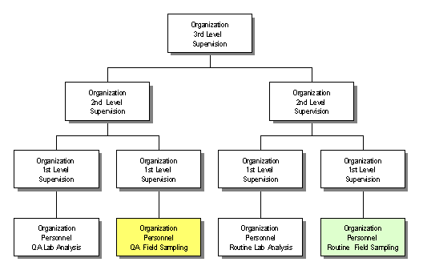

Figure 1. Illustration of independence

Figure 1 illustrates that the QA activities (in yellow) are separated from the monitoring activities (in green) by two levels of management. As mentioned above, for PEP audits, the laboratory preparing the routine PM_{2.5} filters (pre and post-weighing) can not prepare the PEP filters. However, the current national PEP laboratory in EPA Region 4 is capable of functioning as the independent laboratory for the tribe. The TAMS laboratory in Las Vegas can also provide this function as long as the tribe does not send its routine filters to the TAMS laboratory.

Adequacy--

The adequacy requirements for the NPAP and PEP Program have been published to ensure that these programs, if implemented by the tribes, achieve the optimum levels of accuracy, precision and bias in the required measurements. The specific, more detailed requirements are found in Attachments 2 and 3. However, they can be summarized as follows:

PEP Adequacy --

- Primary quality assurance organizations with 5 or less PM_{2.5} monitoring sites would be required to have 5 valid audits per year distributed across the 4 quarters; primary quality assurance organizations with greater than 5 sites would be required to have 8 valid audits per year distributed across the 4 quarters.
- 100 percent completeness (meaning whatever it takes to get 5 or 8 valid samples).
- All samplers subject to an audit within 6 years.
- Data submission to AQS.
- Trained/certified by EPA to perform audit.
- Conforming to the important aspects of the federally implemented PEP Field and Laboratory SOPs and quality assurance project plan requirements.
- Incorporation of PEP in the monitoring organization’s quality assurance project plan.

NPAP Adequacy --

- Performing audits at 20 percent of monitoring sites within a primary quality assurance organization each year with a goal of all sites audited in a 5-7 year period.
- Data submission to AQS.
- Development of a delivery system that will allow for the audit concentration gas to be introduced to the probe inlet where logistically feasible.
- Use of audit gas (CO, SO₂ and NO₂) that is NIST certified and validated once a year and an ozone generator that is verified quarterly.
- For national comparability, validation/certification with the EPA NPAP program through collocated auditing, at an acceptable number of sites each year. The comparison tests would have to be no greater than 5 percent different from the EPA NPAP results.
- Incorporation of NPAP in the monitoring organization’s quality assurance project plan.

In many (but not all) cases the tribe would have to acquire the necessary capital equipment to implement the performance evaluation. EPA may be able to work with the tribes for loans of NPAP or PEP equipment but arrangements would need to be made at local levels such as the EPA Regions or the TAMS Center.

On May 17, 2006 a memo was drafted by EPA, OAQPS asking the EPA Regions to poll their state and local monitoring organizations to determine which organizations planned on implementing their own PEP or NPAP and which wanted continued federal implementation. Only one state opted to implement the PEP and three decided to implement NPAP. The overwhelming majority continue to use the federally implemented program. Similarly, starting in 2007, the tribal monitoring organizations implementing monitoring for comparisons to the NAAQS will have to decide whether they will implement the PEP or NPAP programs or allow for federal implementation of the programs. Tribes implementing monitoring for other objectives but want to participate in these programs will need to communicate this to the EPA Regions. EPA will develop a communication schedule with the tribal monitoring organizations and the EPA Regions that will allow these decisions to be made in time to schedule audits (if the tribes are requesting federal implementation) for the following calendar year.

What is considered “Self-Implementation”?

The requirement for self-implementation is meeting the adequacy and independence requirements. Self-implementation can be met by:

- Tribal monitoring organization performing the audits themselves (meeting all independent and adequacy requirements).
- One tribal monitoring organization auditing another.
- Cooperation among states and tribes for auditing.
- Tribes working together and hiring internally or externally for audits.
- Other mechanisms like working with various organizations (TAMS, others) for the implementation of audits. This might include borrowing federal equipment as mentioned earlier.

Any of these methods can provide effective implementation of the programs and potentially at costs that might be less then the federally implemented program. Some of these methods would allow the tribes to build technical capabilities.

If we opt for Federal implementation, can we afford it?

As described in the May 17th memo, most EPA Regions use the Environmental Service Assistance Team (ESAT) Contract run by the Office of Superfund Remediation and Technology Innovation (OSRTI) to implement both the NPAP and PEP. This contract supports each EPA Region so the personnel that implement the NPAP and PEP are stationed close to the Regional Offices.

Figure 2 provides the key planning aspects of the federally implemented program that must be completed within the specified time frames in order to ensure that funding will continue at an adequate level. Since the federally implemented program is funded with STAG funds, the timeline is dictated by the grant process. Each year OAQPS will need to determine which tribes will plan on implementing NPAP or PEP, and which will opt to utilize the federally implemented program. These decisions need to be made one year in advance of implementation. Figure 2 provides an example timetable of the key decisions that would be made in CY07 for a CY08 implementation. Information related to each task in Figure 2 is described in Table 2.

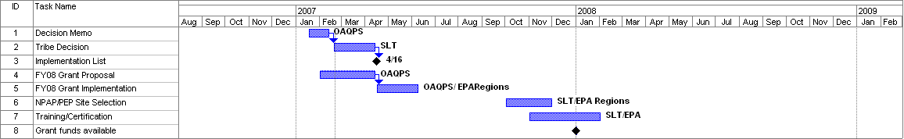
Figure 2 Example Planning Timeline in CY07 for CY08 Implementation

Table 2. Planning Timeline for Federal Implementation.
Task 1 | Decision Memo  January | This memo, sent by the EPA Regions, will alert the tribes about making a decision to implement NPAP/PEP or to redirect funds to EPA for implementation.
Task 2 | Tribal Decision  Jan-April | Tribes will make an implementation decision and inform the appropriate EPA Regional contact. The Regions would need to know how many gaseous monitoring sites and how many PM2.5 sites are in the tribes (based on primary quality assurance organizations) monitoring network. This would determine the number of required NPAP and PEP audits.
Task 3 | Implementation List  April | OAQPS will create a list of all primary quality assurance organizations implementing NPAP or PEP itself or utilizing the Federal program and will be posted on AMTIC.
Task 4 | Grant Proposal  Jan-April | EPA, in coordination with the EPA Regions and the tribes will develop the grant package. EPA will include a redirection of STAG funds for those organizations who have requested federal implementation.
Task 5 | Grant Implementation  April-June | OAQPS will develop the grant guidance document which provides for the funding of the federally implemented program for the coming year.
Task 6 | Site Selection  October-November | In order to develop appropriate contract costs for the calendar year, sites for both the PM_{2.5} PEP and the NPAP are selected by the tribe and EPA in this time period.
Task 7 | Training/Certification | Each year the federally implemented program will train new audit personnel or certify current field auditors. Tribal monitoring organizations will be invited to participate in this training.

Based on years of implementing both the NPAP and PEP programs, a PEP audit will cost about $2,000 per site and an NPAP audit will cost $2,200 per site. These costs are all inclusive, meaning they include all costs associated with implementation, travel, training, capital equipment, consumables, maintenance, repair and data reporting. Once the decision is made for federal implementation, and the tribes have decided on the sites for auditing, the Regions will inform OAQPS of the number of sites and therefore the audit costs for the tribe.

Typically, for the federally implemented program at the state and local monitoring organizations sites, the STAG funds for the audits are redirected to OAQPS prior to distribution to the EPA Regions. OAQPS then determines the number of audits to be accomplished by all monitoring organizations in a particular Region and provides a purchase request to the ESAT audit support contractor in that Region to perform the NPAP and PEP audits. For implementation of these programs for the tribes, with agreement from the EPA Senior Indian Program Manager, EPA anticipates a similar process will be implemented, with annual STAG funds being redirected to OAQPS for those tribes requesting federal implementation.

If we can not do it ourselves and we can’t afford it, are there any other options?

Due to the small number of monitors usually operated by tribal organizations, the percentage of required PEP and NPAP audits are substantially higher (compared to the number of routine monitors) than would be required for most state and local monitoring organizations. However, in order to perform statistically relevant assessments of data quality, EPA can not reduce the number of audits below the current requirement. However, the tribes may be able to meet the requirements and achieve some cost efficiencies by consolidating to a smaller number of primary quality assurance organizations.

Option 1- Consolidation of Tribes to Smaller Number of Primary Quality Assurance Organizations.

Prior to the signing of the Ambient Air Monitoring Regulation by the Administrator on October 17, 2006, the Appendix A requirements aggregated much of the data quality information by “reporting organizations”. Due to some confusion by monitoring organizations on its use, the term “reporting organization” was replaced with the term “primary quality assurance organization (PQAO)”.

The term PQAO has very important implications to quality assurance activities. For example, it is used to determine how many collocated particulate monitors need to be implemented, how many PEP and NPAP audits need to be implemented, and is also used to aggregate data for assessments of completeness, precision and bias. The definition of PQAO as written in Appendix A is provided below.

3.1.1 Each primary quality assurance organization shall be defined such that measurement uncertainty among all stations in the organization can be expected to be reasonably homogeneous, as a result of common factors. Common factors that should be considered by monitoring organizations in defining primary quality assurance organizations include:

(a) Operation by a common team of field operators according to a common set of procedures;
(b) Use of a common QAPP or standard operating procedures;
(c) Common calibration facilities and standards;
(d) Oversight by a common quality assurance organization; and
- Support by a common management, laboratory or headquarters.

EPA believes that the 5 common factors listed are the key criteria to be used when an agency decides the sites to be considered for aggregation to a PQAO. The requirement does not intend that all 5 factors have to be fulfilled but that these factors are considered. However, common procedures and a common QAPP should be strongly considered as key to making decisions to consolidate sites into a PQAO.

Most tribes implementing ambient air monitoring, even within a state, are unique entities and have there own PQAO. However, many state monitoring sites are currently aggregated into one PQAO. There are a few states that have many small local reporting organizations that appear to meet the common factors that describe a PQAO. These reporting organizations could potentially be aggregated into a single PQAO and save the monitoring organization resources by reducing the number of collocated PM monitoring, the number of PEP audits and to some extent, the number NPAP audits. Many of these local organizations have recently informed EPA that they plan to consolidate to a smaller number of PQAOs.

tribes might consider consolidating to a fewer number of PQAOs. Below is an example of the savings that could occur, based upon the current requirements. In this scenario, there are 4 tribal monitoring organizations (tribes A-D) operating both gaseous monitoring sites and PM_{2.5} monitoring sites. Most tribal monitoring organizations do not have extensive networks so the number of sites within each network is realistic. It is assumed that the tribes meet a number of the factors defining a PQAO and could consolidate to one PQAO. Table 3 provides the number and costs of the NPAP audits, the numbers of collocated PM_{2.5} sites needed and the number and costs of the PM_{2.5} PEP audits for each individual monitoring organization as well as for a consolidated PQAO. As the table illustrates, the number of audits and costs of the NPAP decrease by 50% if the tribes consolidate to one PQAO; as does the collocation requirement. In contrast, there is a significant savings in the PEP program. Where it would cost a total of $46,000 to perform 23 audits at the 4 separate tribal PQAOs, it would cost $16,000 for 8 audits under the scenario of the 4 tribes consolidating to one PQAO (PQAO A-D).

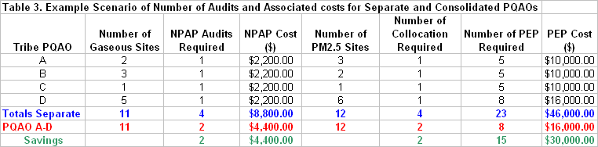

Therefore, there is a significant advantage to tribes consolidating to fewer PQAOs. The consolidation may also help in the development of QA project plans (QAPPs) and standard operating procedure (SOPs) since one QAPP and set of SOPs could serve multiple tribes.

In addition to tribes consolidating with other tribes, the tribes may also consider forming a PQAO with a state monitoring organization. This not only has the advantages mentioned above but since the state organizations are usually larger and have more resources at their disposal, they will have developed many of the QA materials such as the QAPP and standard operating procedures that can then be followed and used by the tribes. So in summary, the following (in order of simplicity) are a few options for PQAO consolidation:

- Consolidation of tribes within a state
- Consolidation of tribes across states within an EPA Region
- Consolidation of tribes with state PQAO
- Consolidation of tribes across EPA Regions

Attachment 4 contains a form that can be distributed to tribes by the EPA Regions in order to gather information on whether a tribe will be considering any of these consolidation techniques and its interest in participating in the NPAP and or the PEP.

NOTE: It must be noted that PQAO consolidation is for QA purposes only and does not have any other political or technical implications. The tribal agency codes and the reporting organization codes in AQS will remain unique to each tribe so the tribe will remain as sovereign entities no matter which consolidation technique is used.

Option 2 -TAMS Center Assistance

In 2007, it is anticipated that the TAMS Center in Las Vegas will receive a trailer that will be outfitted to serve as a NPAP through-the-probe mobile laboratory. This trailer will be used to train and certify auditors to perform NPAP and can be used to perform NPAP audits. In addition, the TAMS Center also has PEP equipment available for loan. The tribes could take advantage of this equipment and possibly combine resources to train an auditor who could service a number of tribes and therefore meet both the independence and adequacy requirements.

In addition to equipment loans, the TAMS Center technical staff may be able to perform a limited number of audits for tribes on a first-come-first-serve basis. The details of this process will be developed in 2007.

Option 3-EPA Regional Assistance

Similar to the TAMS Center (option 2), the NPAP trailers or vehicles in the EPA Regions may be available for loans to the tribes on a first-come-first-serve basis. There are a number of stipulations for the use of the NPAP laboratories that are discussed in Attachment 2. The loan of the equipment would alleviate capital expenditure costs. The PEP equipment may be available for loan but this would need to be negotiated at the EPA Regional level.

Summary

With the new monitoring regulation promulgated on October 17, 2006, EPA wants to ensure that the tribal monitoring organizations are aware of their grant obligations for ambient air monitoring to implement the QA requirements described in 40 CFR Part 58 Appendix A and to report this data to AQS. Although these requirements are specific to sites that will be used for comparison to the NAAQS, they provide for a reasonable assessment of data quality that should be implemented at sites that may be developed for objectives other than NAAQS comparisons. Appendix A requires monitoring organizations to participate in two independent performance evaluation programs; NPAP and PEP. The tribes can either implement these programs itself or utilize the federally implemented programs which will require a redirection of STAG funds to EPA. In order to reduce the costs of these programs, the tribes might consider the following options:

- Consolidation to smaller primary quality assurance organizations (PQAO). This would not only save on PEP and NPAP costs but also on the costs of PM collocations. Federal implementation at these “consolidated” PQAOs would cost each individual tribe less. The tribe might also consider forming a PQAO with a state monitoring organization.
- Tribes consolidating funds for purchasing equipment and training tribal auditors to service a number of tribes. EPA would provide personnel training/certification and would also certify the NPAP and PEP equipment.
- Loans of capital equipment from either the TAMS Center or the EPA Regions on a first-come-first-serve basis.
- Utilizing trained and certified personnel at the TAMS Center to implement audits within to the extent that this is possible or feasible.

American National Standard-Quality Systems for Environmental Data and Technology Programs-Requirements with Guidance for Use (ANSI/ASQC E4-2004)
see www.eenews.net/Greenwire/Backissues/081604/08160403.htm
http://www.epa.gov/ttn/amtic/npepqa.html
http://www.epa.gov/ttn/amtic/40cfr53.html-Final - Revisions to Ambient Air Monitoring Regulations.
http://www.epa.gov/ttn/amtic/npepqa.html; May 17, 2006 Memo to Monitoring Organizations Determination to Implement the National Performance Audit or PM_{2.5} Performance Evaluation Program
40 CFR Part 58 Appendix A Section 3.1.

